Year 7 Religious Studies Homework – Term 1

What are Ultimate Questions?

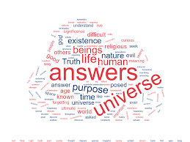

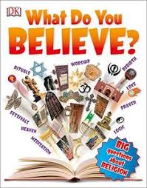

• This homework is to be completed in your own time and should be handed in on the date your teacher tells you. LOC’s and credits are available for the best ones.
• This homework will help with your end of unit assessment. The more effort you put into this homework the better your assessment will be.
• You should be completing all Tasks. Students aiming for the top levels, Secure and Excelling, will show this by the amount of extra detail and research they put into the homework.
• Poor/hurried homework, or if not handed in on time will result in a detention

Task 1
Ask 5 different people this question.
What is the purpose of life?
Write down their answers and their explanations.

Task 2
Draw this table on a separate piece of paper then read the statement below.
‘Miracles prove the existence of God.’
In the table you have drawn research 4 reasons why people might agree with this statement and 4 reasons why they might disagree. Answer in full sentences, justifying your reasons. Examples of miracles can be found on YouTube.
(A miracle is an event that cannot be explained by natural or scientific laws).
Agree | Disagree

Task 3
Produce a poster (A4 maximum) which answers this question.
What happens when we die?
Do you believe in heaven and hell? Does nothing happen when we die? What about reincarnation?
