Year 7 Religious Studies Homework – Term 2

Buddhism
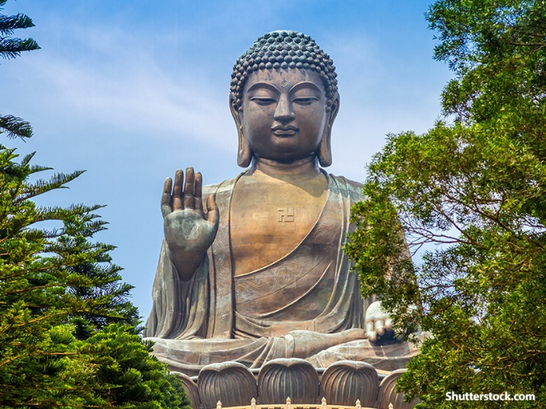

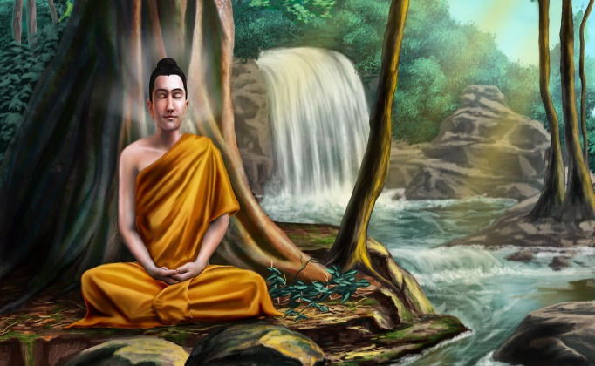
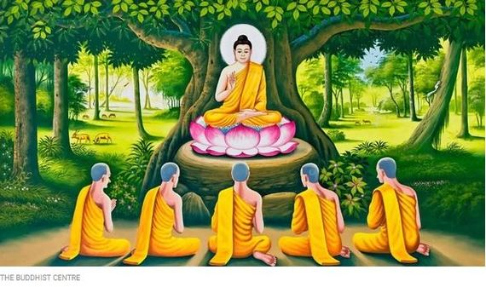

• This homework is to be completed in your own time and should be handed in on the date your teacher tells you. LOC’s and credits are available for the best ones.
• This homework will help with your Right to Write which is also acting as your assessment. The more effort you put into this homework the better your assessment will be.
• You should be completing all Tasks. Students aiming for the top levels, Secure and Excelling, will show this by the amount of extra detail and research they put into the homework.
• Poor/hurried homework, or if not handed in on time will result in a detention

Task 1
Why is Meditation such an important practice in Buddhism?
- Explain what Meditation is and when Buddhists will use it.
- Give at least two reasons explaining the benefits of Meditation.
Youtube is a good place to look to see examples of Buddhist meditation and music.
Task 2
During this topic we have looked at many different parts of Buddhism and specifically their beliefs and practices. These include the Four Noble truths, the Eightfold path and the 3 marks of life (Annica, Dukkha, Anatta).
Write a diary entry from the perspective of a 12 year old Buddhist where you explain what they have done in the day and how they have modelled the Buddhist teachings.
An example paragraph is below. If you would prefer to storyboard this task instead you can do.
Dear Dairy,
Today was a difficult day at school. A boy in my class was really irritating me and I really wanted to punch him. However, I remembered how important it was for Buddhists to do the right action and the right speech. I therefore decided to ignore him and instead of punching him I took 3 deep breaths which calmed me down. By doing this I practiced right speech and right action.
Task 3
Many religions place great importance on rituals following the death of someone.
Find two different (contrasting) rituals to do with death and mourning in Buddhism. Explain what they do and why they do it.
Now do the same for at least one of the other major religions.
- Christianity
- Islam
- Hinduism
- Sikhism
- Judaism

