**Issue 734 Friday 5th May 2023 Next Week is Week 2**

### Description: http://www.af.mil/DesktopModules/SocialMediaFeed/Templates/AirForce/Images/twitter-bird-white-on-blue.png All Enquiries: 020 8270 6222 Website: [www.jorichardson.org.uk](http://www.jorichardson.org.uk)

### Email: [headteacher@jorichardson.org.uk](mailto:headteacher@jorichardson.org.uk) Twitter: @JRCS_School

Description: Bird - black**HEADTEACHER’S NEWS**

**Gold Seagull**

Congratulations to this week’s Gold Seagull winners:

Shalom Year 7 – Double winner

Gloria Year 8 – Double winner

Kacie-Ann Year 8

Klarisse Year 8

Ria Year 8

Samuel Year 8

Chelsee Year 8

**Upcoming dates**

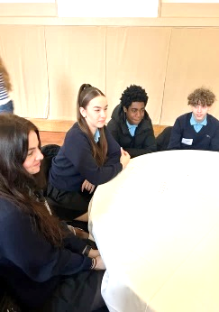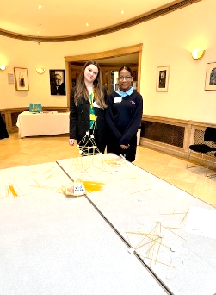Monday 8th May: Extra Bank Holiday for the King’s coronation. School closed.

Wednesday 10th May: Year 7 Progress Evening 3.45pm to 6.30pm.

It was wonderful to see so many students in their cultural dress today. Well done to all those students that performed in our showcase.

We also held a coronation picnic for our students who were awarded gold or platinum on their report rankings. An amazing achievement. We hope you enjoyed your afternoon, well done!

**Keeping students safe**

Can I ask parents/carers to ensure that students go straight home at the end of the school day so that we can keep students safe. Please ensure your child does not hang around in the parks or at the shops. We have unfortunately seen a recent increase in serious youth violence. It is important that you know where your child is at the end of the school day and encourage them to come straight home after school.

Don’t forget that Monday is an extra bank holiday, and we look forward to welcoming students back on Tuesday 9th May.

Miss Keane

Headteacher

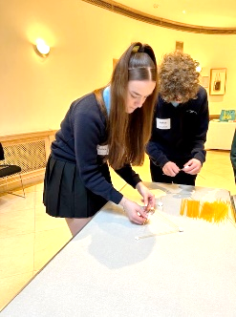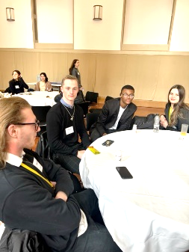**Year 10 and 12**

Before the half term spring break, a selected number of Year 10 and 12 students from our Citizenship and Politics classes, attended the Halcyon London International School.

The students were given the opportunity to take part in a student led conference, where they participated in three interactive workshops which focussed on controversial issues; as well as having a guest speaker, Eva Thorne, who

came along to speak about Equity v Equality.

I am so proud of how our students were able to come out of their shells and participate in all discussions. They all absolutely represented our school really well. They were sensible and well behaved on the commute there and back and did the school proud in terms of manners and behaviour during our time at the Halcyon London International School. We too hope to be able to organise and run a similar workshop here at JRCS to host our Halcyon colleagues.

Congratulations to:

**Year 10 students**:

Charley, Emmanuel, Joshua, Keyra, Donel, Rougi, Lara andMazey

**Year 12 students:**

Edisona, Elvinas, Donte and Dylan

Miss Mambuini

Teacher of PDE

**Media**

On Thursday 27thApril, Ms Harland visited an ex-JRCS student at their university. Ellie left JRCS two years ago to study Television Production at Ravensbourne University.

Ellie and her peers had an assessment for their course and had created a live production called "Wingmum". The concept is that "mum knows best" and chooses a date for their child. Ms Harland was asked to be "mum" for the production.

Each Ravensbourne student had a different role, from camera operator (which is the field Ellie would like to enter), to director, floor manager, producer, even presenter.

Ellie's role for this production was lighting designer, so she set up the rig and sourced the hot pink and blue lights on set. JRCS has a long history of supporting alumni students.

If you would like to watch the recording of the live the show, click on this link (skip the title screen)<https://www.youtube.com/live/tbPHfYOLFd4?feature=share>

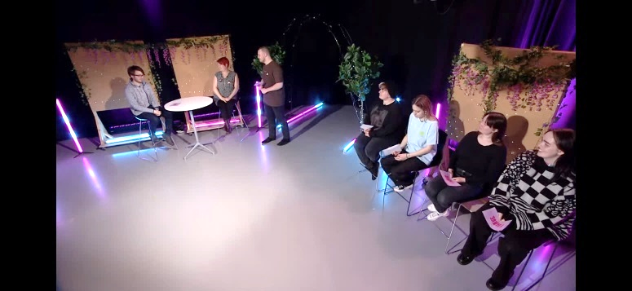

Miss Harland

Head of Media Studies

|  |  |  |  |  |
| --- | --- | --- | --- | --- |
| **Weekly Outline of Out of School Hours Learning Activities - Summer 2023** | | | | |
| **Club** | **Year Group** | **Staff** | **Time** | **Venue** |
| **Monday** | | | | |
| **Orchestra** | **7, 8, 9,10 & 11** | **Mr Jenner** | **8:15am - 8:50 am** | **MU1** |
| **KS3 Badminton/Table Tennis** | **7, 8 & 9** | **Mr Watts** | **12:30pm – 1:00pm** | **Sports Hall** |
| **KS4 Badminton/Table Tennis** | **10 & 11** | **Miss Pridie** | **1:30pm – 2:00pm** | **Sports Hall** |
| **SDD Homework Club** | **7, 8 & 9** | **SDD staff** | **12:30pm - 1:00pm** | **SDD** |
| **SDD Homework Club** | **10 & 11** | **SDD staff** | **1:30pm - 2:00pm** | **SDD** |
| **Year 9 Dance Club** | **9** | **Mr Hazelwood** | **1:30pm - 2:00pm** | **DA1** |
| **Year 9 Football** | **9** | **Mr Cully** | **3:15pm – 4:15pm** | **Astro** |
| **Tuesday** | | | | |
| **Year 9 Football** | **Year 9** | **Mr Bashir** | **7:45am - 8:30am** | **Astro** |
| **KS3 Basketball** | **7, 8 & 9** | **Mr Thomas/Mr Watts** | **7:44am - 8:15am** | **Sports Hall** |
| **Vocal Group** | **7, 8, 9, 10 & 11** | **Miss Harris** | **8:15am - 8:55 am** | **MU1** |
| **Drama Club starts 15/5** | **7, 8, & 9** | **Ms Willis** | **12:30pm – 1:00pm** | **DR2** |
| **SDD Homework Club** | **7, 8 & 9** | **SDD staff** | **12:30pm - 1:00pm** | **SDD** |
| **SDD Homework Club** | **10 & 11** | **SDD staff** | **1:30pm - 2:00pm** | **SDD** |
| **NEW – Art Club** | **7, 8 & 9** | **Ms Levene** | **12:30pm - 1:00pm** | **AR3** |
| **KS3 Rounders** | **7, 8 & 9** | **Miss Pridie** | **3:00pm – 4:00pm** | **Field** |
| **Cricket** | **All** | **Mr Howard** | **3:00pm – 4:00pm** | **Field** |
| **KS3 Rounders** | **7, 8 & 9** | **Miss Pridie** | **3:00pm – 4:00pm** | **Field** |
| **Year 7 Rugby** | **7** | **Mr Kersey** | **3:15pm - 4:15pm** | **Field** |
| **Bronze DofE Expedition** | **Year 10 invited** | **Ms Montague** | **3:05pm - 4:35pm** | **SD3 starts 24/1** |
| **DT Club** | **KS3** | **Ms Kamal/ Ms Dorma** | **3:05pm - 4:05 pm** | **DT6** |
| **Food Club** | **KS3** | **Ms Damian/ Ms Hinds** | **3:05pm - 4:05 pm** | **FC1** |
| **Spanish Club (Week 2 only)** | **9** | **Miss Fernandez** | **3:05pm – 4:00pm** | **MFL3** |
| **Wednesday** | | | | |
| **Year 9 Football** | **Year 9** | **Mr Bashir/Mr Cully** | **7:45am - 8:30am** | **Astro** |
| **Fitness Club** | **All (Girls Only)** | **Miss Pridie** | **7:45am – 8:15am** | **Fitness Suite** |
| **Year 10 Band** | **10** | **Mr Jenner** | **8:15am - 8:50am** | **MU1** |
| **Volleyball** | **All** | **Miss Pridie** | **7:45am - 8:15am** | **Sports Hall** |
| **Indoor Cricket** | **All** | **Mr Howard** | **1:30pm - 2:00pm** | **Sports Hall** |
| **Year 7 Dance Club** | **7** | **Miss England** | **1:30pm - 2:00pm** | **DA1** |
| **Pride and Allies** | **All** | **Ms Brookman and Ms Belloni** | **1:30pm - 2:00pm** | **RS1** |
| **Year 9 Football** | **9** | **Mr Bashir** | **2:00pm – 3:00pm** | **Astro** |
| **Thursday** | | | | |
| **Year 9 Football** | **Year 9** | **Mr Bashir** | **7:45am - 8:30am** | **Astro** |
| **Fitness Club** | **All** | **Mr Thomas** | **7:45am – 8:15am** | **Fitness Suite** |
| **Wind Band** | **7, 8, 9, 10 & 11** | **L Ellis** | **8:15am - 8:55am** | **MU2** |
| **Panathlon Club** | **7, 8 & 9 invited** | **Ms Montague** | **10:00am - 10:30am** | **Sports Hall** |
| **Junior maths challenge club** | **7 & 8** | **Ms Aragroug and Ms Moody** | **12:30pm - 1:00pm** | **MA4** |
| **KS3 Volleyball** | **7, 8 & 9** | **Miss Jones** | **12:30pm – 1:00pm** | **Sports Hall** |
| **SDD Homework Club** | **7, 8 & 9** | **SDD staff** | **12:30pm - 1:00pm** | **SDD** |
| **SDD Homework Club** | **10 & 11** | **SDD staff** | **1:30pm - 2:00pm** | **SDD** |
| **GCSE Dance Technique** | **10** | **Miss England** | **1:30pm - 2:00pm** | **DA1** |
| **Year 13 Debate Club** | **13** | **M Ribbons and F Jabbar** | **1:30pm - 2:00pm** | **SF2** |
| **KS3 Dance Company** | **Audition 7, 8 & 9** | **Miss England** | **3:00pm - 4:30pm** | **DA1** |
| **Athletics** | **All** | **All PE Staff** | **3:05pm – 4:30pm** | **Field** |
| **Year 8 Rugby** | **8** | **Mr Kersey** | **3:15pm - 4:15pm** | **Field** |
| **Spanish Club (Week 1 only)** | **All** | **Miss Fernandez and Ms Damian** | **3:15pm - 4:15pm** | **MFL3** |
| **Electronics Club** | **KS3** | **Ms McKenzie** | **3:05pm - 4:05 pm** | **DT3** |
| **Computing Intervention** | **10 & 11** | **Mr Cambell** | **3:05pm - 4:05 pm** | **IT1** |
| **Textiles Club** | **7, 8 & 9** | **Miss Mir** | **3:05pm - 4:05 pm** | **DT4** |
| **Wellbeing Club** | **All** | **Ms Draisey** | **3:00pm – 4:00pm** | **Conference rm (library)** |
| **NEW – Photography Club** | **9 & 10** | **Ms Franz** | **3:10pm – 4:15pm** | **AR2** |
|  |  | **Friday** |  |  |
| **Music Theory Club** | **10 & 11** | **Mr Jenner** | **8:15am - 8:55am** | **MU1** |
| **Year 8 Dance Club** | **8** | **Miss England** | **10:00am -10.30am** | **DA1** |
| **KS3 Maths puzzle club** | **7,8 & 9** | **Ms Morozova** **and Ms Malik** | **12:30pm - 1:00pm** | **Maths atrium** |
| **KS3 Girls Football** | **7, 8 & 9** | **Miss Pridie** | **1:30pm – 2:00pm** | **Sports Hall** |
| **SDD Homework Club** | **7, 8 & 9** | **SDD staff** | **12:30pm - 1:00pm** | **SDD** |
| **SDD Homework Club** | **10 & 11** | **SDD staff** | **1:30pm - 2:00pm** | **SDD** |
| **Year 11 Football** | **11** | **Mr Cully/Mr Bashir** | **3:15pm - 4:15pm** | **Astro** |
| **GCSE Intervention** | **11** | **Miss England** | **3.00pm - 4.30pm** | **DA1** |
| **Silver DofE** | **10** | **Ms Montague** | **3:00pm – 4:00pm** | **SD3** |
| **NEW - Computing Intervention** | **10 & 11** | **Mr Cambell and Miss Hibbert** | **3:10pm – 4:00pm** | **IT1** |



**Schools and Colleges Early Support Service**

**Information regarding Webinars for Parents and Carers May 2023**

Dear Parents/Carers,

We would like to invite you to attend the May 2023 webinar series specially tailored for parents/carers of adolescents, in collaboration with the Schools and Colleges Early Support Service.

Topics have been chosen to reflect core developmental processes in adolescence and common difficulties parents can struggle with. The content is psychoeducational, strategy-based and solution focused. The webinars will cover the following topics:

* Anxiety in adolescence: how can parents help?
* Adolescent self–harm: how to make sense of it and when to seek support
* Weathering the storms of strong teen emotions: do’s, don’ts and when to consider talking to someone
* Building resilience, staying connected and nurturing your relationship with your teen
* Managing teen behaviour that challenges: tips and tricks

We have two **NEW** webinars taking place this term:

* Supporting a young person at exam times
* Low mood in adolescence

Further details on each webinar are below. To register please click on the relevant Zoom link.

**Supporting a young person at exam times**

**Thursday 11 May 5-6pm**

Venue: Virtual via Zoom

Tests and exams can be a challenging part of school/college life for young people and their parents or carers. Supporting young people through exams is all about reducing stress, optimising wellbeing and putting good study processes in place.

Parents/carers play a vital role in helping their young people maintain a positive outlook in the run-up, during and after exams are over.

This webinar will offer advice around communicating with your young person at exam time, help you to spot the signs of stress and offer you strategies to support your young person in managing exam stress in a healthy way.

Our Patron: **Her Royal Highness The Princess of Wales**

Anna Freud National Centre for Children and Families is a company limited by guarantee, company number 03819888,   
and a registered charity, number 1077106.

***Register in advance for this meeting:***

**Thursday 11 May:**

<https://annafreud.zoom.us/meeting/register/tJYlcuqqrjwvE9fKxqQalRRt5tuk5zqslwM4>

*After registering, you will receive a confirmation email containing information about joining the meeting.*

**Low mood in adolescence**

**Tuesday 16 May 12:30-1:30pm**

Venue: Virtual via Zoom

Low mood does not just affect adults. Young people can experience low mood too. Common signs of low mood often include sadness that does not go away, feeling irritable all of the time, not being interested in things that used to be enjoyed, feeling tired and exhausted a lot of the time. Things that might increase low mood include family difficulties, bullying, bereavement, parental separation, friendship issues. Our webinar will offer some insight into spotting the signs and symptoms of low mood, understand why young people are vulnerable to experiencing this and offer evidence-based strategies to support a young person.

***Register in advance for this meeting:***

**Tuesday 16 May:**

<https://annafreud.zoom.us/meeting/register/tJAvd-irqDIvE9IaTqNms83Y64Ga9ubPGoAf>

*After registering, you will receive a confirmation email containing information about joining the meeting.*

**Anxiety in adolescence: how can parents help?**

**Tuesday 9 May 5-6pm** AND **Monday 15 May 12:15-1:15pm**

Venue: Virtual via Zoom

It is normal to sometimes feel anxious, however for some adolescents, anxiety can become a significant problem that stops them from doing things, e.g., talking to new people, going out with friends, or doing their best in exams. The focus of this webinar will be on what parents/carers can do to help their teens who are experiencing anxiety. It will cover when anxiety is normal vs. problematic, common anxieties during adolescence (exam stress, social anxiety and worries about identity and development), the relationship between parent-child anxiety, and how and when to access support for you and your child. We will also discuss a couple of ‘real world’ examples of common adolescent anxieties and different strategies that may be helpful in those situations.

***Register in advance for this meeting:***

**Tuesday 9 May:**

<https://annafreud.zoom.us/meeting/register/tJwrdOqspzwrHdYVhrsl6hl3yTK1RWwTo83v>

Our Patron: **Her Royal Highness The Princess of Wales**

Anna Freud National Centre for Children and Families is a company limited by guarantee, company number 03819888,   
and a registered charity, number 1077106.

**Monday 15 May:**

<https://annafreud.zoom.us/meeting/register/tJ0pfuysqjIvE9LwkJ5rShm3eToPFzzLfk1->

*After registering, you will receive a confirmation email containing information about joining the meeting.*

**Building resilience, staying connected and nurturing your relationship with your teen**

**Wednesday 10 May 12:30-1:30pm**

Venue: Virtual via Zoom

Adolescence is a time of insecurity, strong feelings and growing autonomy which naturally affects the parent-child relationship and requires parents to find new ways of connecting with their teenagers. Parents may feel left out and worried, and they may experience a sense of loss over the relationship they used to have with their children when they were younger. This webinar offers ideas on how to maintain and build trust with teenagers, how to stay connected and how to nurture the relationship with their teen. Places on this webinar won’t be limited and there will be an opportunity to ask questions at the end.

***Register in advance for this meeting:***

**Wednesday 10 May:**

<https://annafreud.zoom.us/meeting/register/tJAuc-6trDIoE9YDK4s_0XzkEFdBriL4r4FK>

*After registering, you will receive a confirmation email containing information about joining the meeting.*

**Managing teen behaviour that challenges: tips and tricks**

**Thursday 11 May 12:30-1:30pm**

Venue: Virtual via Zoom

Most adolescents will at some stage in their development engage in behaviour that parents find challenging and worrying, for instance, substance misuse, being overly argumentative and rejecting, oppositional behaviour and excessive social media use. It can become difficult for parents to find ways of discussing their concerns with their teens who may increasingly not want to hear any advice their parents have to offer. This webinar will provide an overview of adolescent development and the brain, including common challenging behaviours during adolescence. It will discuss different parenting styles and offer tips for parents on how to approach and discuss challenging behaviour with teens, and how to set boundaries. Places on this webinar won’t be limited and there will be an opportunity to ask questions at the end.

***Register in advance for this meeting:***

**Thursday 11 May:**

<https://annafreud.zoom.us/meeting/register/tJ0kd-qupj0oEtdiAtXV_AhisXUG0iQl8KwJ>

*After registering, you will receive a confirmation email containing information about joining the meeting.*

Our Patron: **Her Royal Highness The Princess of Wales**

Anna Freud National Centre for Children and Families is a company limited by guarantee, company number 03819888,   
and a registered charity, number 1077106.